Frequently asked questions

Mount Waverley water main renewal project

**What is happening?**

Melbourne Water is renewing the Mount Waverley water main (M76) located in High Street Mount Waverley. See map below for location.

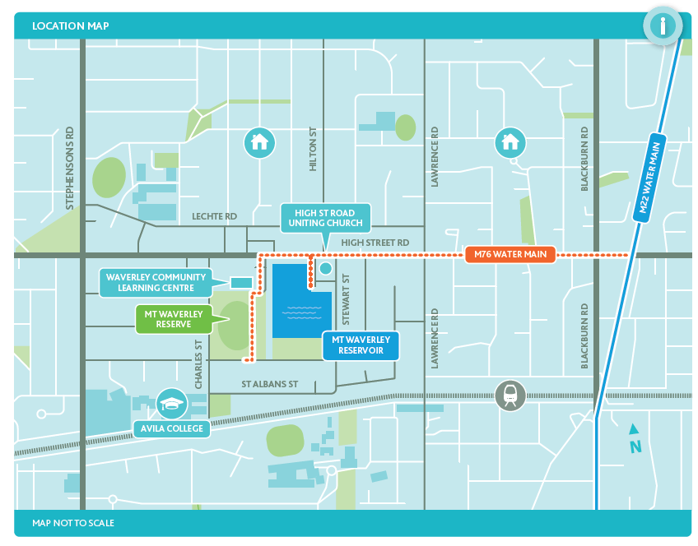Project area map: Mount Waverley water main renewal

**Why is this important?**

The M76 water main plays an important role in transferring water between Silvan Reservoir, Mitcham Reservoir and Mount View Reservoir.

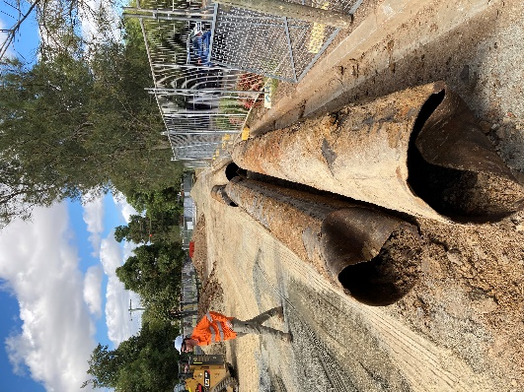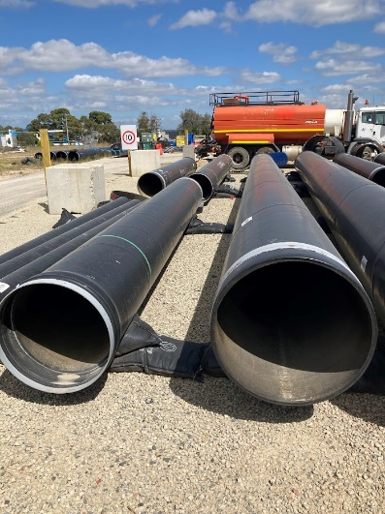

***80-100yr old pipes***

***New replacement pipes***

It was constructed in 1928, has been repaired and relined in the past, and is nearing the end of its service life.

Renewal of the water main will ensure the supply of safe and reliable water now and into the future for our customers and the wider community.

**Why can't the pipe just be repaired?**

Due to the age of the pipes, continually repair is not an option. By laying new pipes we can ensure a life expectancy of 100-150 years.

**Can the water mains go somewhere else?**

Water mains connect existing assets such as Mount Waverley, Mitcham, Mount View and Silvan water reservoirs and supply water to water retailers networks. These pre-determined connection points dictate the alignment for new water mains.

Most of the M76 water main renewal work will be located within High Street Road.

Alternative alignments for new water supply pipelines are limited because existing nature strip contain a number of other services and infrastructure such as drainage, gas, telecommunications etc.

**When will works occur?**

The timing of the Mount Waverley water main renewal project is critical to ensuring safe and reliable water for residents and businesses in Melbourne's South Eastern suburbs.

A contractor has been appointed to provide design and construct services for the water main renewal. Design work is currently underway and works within Mount Waverley Reserve are planned to commence in July 2023. The work front will slowly move along High Street Road, finishing at the pipe track near the intersection of High Street Road and Blackburn Road in late 2024.

**Will any trees be removed?**

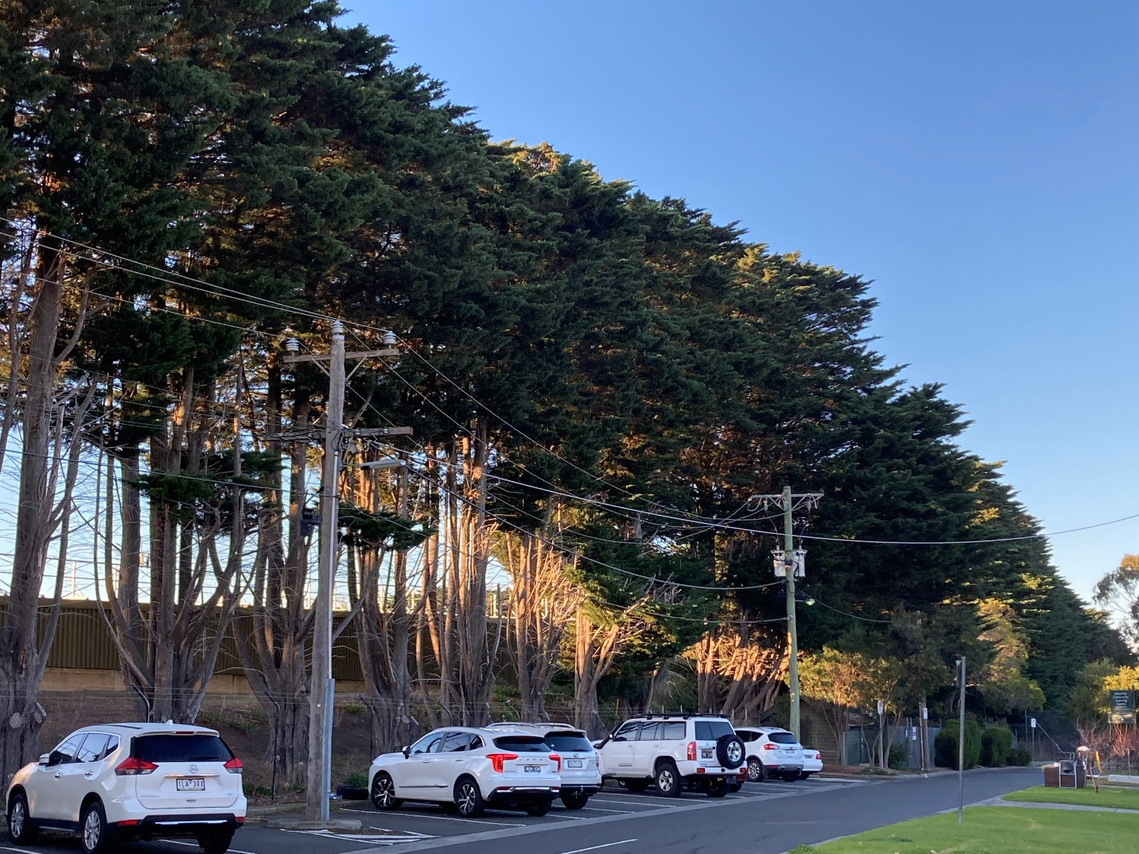An arborist has assessed the trees surrounding Mount Waverley Reservoir and reported that they are coming to the end of their life. Due to the risks of branches and limbs falling onto our neighbours or damaging the reservoir, the trees will be removed in stages.

The trees near the work area being removed first as trenching and working beside trees can undermine their root systems, making them more unstable and unsafe.

The second stage of tree removal will occur in 2-3 years as part of a later project to strengthen the reservoir embankment.

Some additional trees along the alignment and within Mount Waverley Reserve will also be removed or trimmed.

Careful vegetation management is important for the following reasons:

* The roots of trees and shrubs close to water mains can cause corrosion, blockages and damage, impacting water supply and reducing the service life of water main pipes.
* Trenching and working beside trees can undermine their root systems, making them unhealthy, unstable and unsafe.
* We will also prune some trees along High Street Road to reduce the possibility of damage from machinery during our works.

Melbourne Water takes tree removal seriously and seeks to avoid it where possible.

A planning permit has been submitted for the first stage of tree removals.

**What steps have been taken to avoid tree removal?**

A thorough process was undertaken to minimise tree removal, including;

* adjusting the new water main location to avoid trees where possible.
* design efficiencies that minimise the project's footprint, and
* use of construction methodologies aimed at minimising impacts to tree roots.

We have worked closely with an arborist and Monash Council to avoid tree removal wherever possible. Unfortunately, some trees will still need to be removed.

**Are the trees identified for removal being replaced?**

We recognise that trees are important for the community, and therefore, it is important for the project to consider offsetting or replacing some of the trees. We are working closely with Monash Council to develop a reinstatement strategy that benefits the community. Reinstatement works will occur at the end of the project in late 2024.

**What about flora and fauna?**

A flora and fauna assessment has been completed for the work area. This assessment determine that the environmental conditions of the site are of a heavily degraded, urbanised nature. Therefore, it is unlikely threatened species habitat or threatened communities occur within the project area.

**How will wildlife be protected?**

A qualified wildlife handler (ecologist or zoologist) will be onsite during any tree removal to:

* complete a wildlife pre-clearance check before construction
* checking the site for fauna and marking trees likely to have habitat.
* attempting to catch and relocate fauna (without causing it distress). If this isn't possible, the contractors will move to the next tree and return to try again later.
* relocating nests or nesting boxes.

It is preferable to relocate fauna within the same site. If this is not possible, the wildlife handler will advise on a relocation strategy.

**Will my water service be disrupted?**

Your water supply is not expected to be interrupted during our works. If you experience any issues with your water, please call Yarra Valley Water on 13 27 62.

**What are the work hours for the construction crew?**

Most construction works will occur during standard construction hours of Monday to Friday between 7 am and 6 pm and Saturdays from 7 am to 1 pm.

Nightworks may be required at critical road crossings to minimise traffic disruption. Residents and businesses will be advised if works are necessary outside of these hours.

**Will the works generate any noise, dust and vibration?**

Some noise, dust and vibration from excavators, trucks and other machinery will be unavoidable during construction. Where possible, our work crews will try to minimise this by varying work activities and deploying water carts.

**What are the impacts on traffic (parking, cyclists and pedestrians)?**

There will be changes to traffic conditions, including lane and road closures, parking restrictions and alternative driveway access for some properties.

The water main replacement along High Street Road will have an approximate 500m long work front that will shift 20-30m every few days as construction progresses. Traffic controllers will direct traffic, pedestrians and cyclists around the work area during construction.

We encourage you to be careful around work areas and observe signage.

**What steps are being taken to engage with the community about this project?**

A project introduction bulletin will be distributed to approximately 2,000 households, in the local area, in April 2023. The newsletter highlights the need for the project, the methodology being used, project benefits and impacts, including the need for tree removal and trimming. A copy is available on the project web page: [www.melbournewater.com.au/M76](http://www.melbournewater.com.au/M76).

Information sessions are planned, at Mount Waverley Reserve on the following dates:

DATE: Thursday 27 April 2023

TIME: 3:00-4:30pm

DATE: Saturday 6May

TIME: 9:30-11:30am

Melbourne Water will continue to maintain contact with the community through door knocks, notification letters, phone calls and site signage to ensure you are informed of upcoming works.

To keep you up to date with what we are doing, how the works are progressing and when we will be in your area, we will also provide web updates at: [www.melbournewater.com.au/M76](http://www.melbournewater.com.au/M76).

Or you can contact the project team directly at:

Email: [M76@melbournewater.com.au](mailto:M76@melbournewater.com.au)

Phone: 1800 931 106